― Review Articles / Original Research / Short Communications / Case Reports / Letters to the Editor ―（←Select one. Times New Roman 12pt）(Please delete red characters.)

Hypometabolism in the supplementary motor area is related to dysphagia in Parkinson’s disease and multiple system atrophy (Title, Times New Roman 14pt)

Taro Tohoku ¹⁾²⁾, Hanako Miyagi ²⁾ and Jiro Yamagata ¹⁾ (Full Names, Times New Roman 12pt)
- Department of Occupational Therapy, Faculty of Health Sciences, Yamagata Prefectural University of Health Sciences, 260 Kamiyanagi, Yamagata City, Yamagata, 990-2212, Japan (Affiliations, Times New Roman 10pt)
- Department of Neurology, Seihoku University, 1-2-3 Miyagino-machi, Miyagino-ku, Sendai, Miyagi, 987-6543, Japan

ABSTRACT (Abstract should be written here within 250 words. Times New Roman font in 10-point must be specified.)
Objective: The detailed distribution of -----------------------------------------------------------------------------------------------------------------------------------------------------------------------------------------------------------------------------------------------------------------------------------------------------------------------------------------------------------------.
Methods: The participants ---------------------------------------------. --------------------------------------------------------------------------------------------------. --------------------------------------------------------------------------------------------------------------------------------------------------------------------------------. --------------------------------------------------------------------------------.
Results: -----------------------------------------------------------------------------------------------------------------------------------------------------------------------------. ---------------------------------------------------------------------------------------------------------------------------------. ------------------------------------------------------------------------------------------------------------------------------. ----------------------------------------------------------------------------------------.
Conclusions: ----------------------------------------------------------------------------------------------------------------------------------------------------------------------------------. -------------------------------------------------------------------------------------------------. --------------------------------------------------------------------------------------------------------------------------------------------------.
Keywords: (Five or less, Times New Roman 9pt)

INTRODUCTION

Parkinson’s disease (PD) is (Times New Roman 10pt)----------------------------------------------------------------------------------------------------------------------------------------------------------------------------------------------------------------------------------------------------------------------------------------------------------------------------------------------------------------------------------------------------------------------------------------.

Received 21 May, 2025. Revised 21 June, 2025. Accepted 21 October, 2025.
Correspondence to Dr Akio Kikuchi: xxx@xxx.xx (Times New Roman 9pt)
Multiple system atrophy (MSA) is ---------------------------------------------------------------------------------------------------------------------------------------------------------------------------------------------------------------------------------------------------------------------------------------------------------------------------------------------------------------------------------------------------------------------------------------------------------------------------------------------------------------------------------------------------------------------------------------------------------------------------------------------------------------------------------------------------------------------------------------------------------------------------------------------------------------------------------------------------------------------------------------------------------------.
-----------------------------------------------------------------------------------------------------------------------------------------------------------------------------------------------------------------------------------------------------------------------------------------------------------------------------------------------------------------------------------------------------------------------------------------------
----------------------------------------------------------------------------------------------------------------------------------------------------------------------------------------------------------------------------------------------------------------------------------------------------------------------------------------------------------------------------------------------------------------------------------------------------------------------------------------------------------------------------------------------------------------------------------------------.

METHODS
Participants. ----------------------------------------------------------------------------------------------------------------------------------------------------------------------------------------------------------------------------------------------------------------------------------------------------------------------------------------.
----------------------------------------------------------------------------------------------------------------------------------------------------------------------------------------------------------------------------------------------------------------------------------------------------------------------------.
----------------------------------------------------------------------------------------------------------------------------------------------------------------------------------------------------------------------------------------------------------------------------------------------------------------------------.
----------------------------------------------------------------------------------------------------------------------------------------------------------------------------------------------------------------------------------------------------------------------------------------------------------------------------.
----------------------------------------------------------------------------------------------------------------------------------------------------------------------------------------------------------------------------------------------------------------------------------------------------------------------------.
-------------------------------------------------------------------------------------------------------------------------------------------------------------------------------------------------------------------------------------------------------------------------------------------------------.
Standard protocol approvals, registrations, and patient consents. -----------------------------------------------------------------------------------------------------------------------------------------------------------------------------------------------------------.
----------------------------------------------------------------------------------------------------------------------------------------------------------------------------------------------------------------------------------------------------------------------------------------------------------------------------.
-------------------------------------------------------------------------------------------------------------------------------------------------------------------------------------------------------------------------------------------. Statistical analysis. -----------------------------------------------------------------------------------------------------------------------------------------------------------------------------------------------------------------------------------------------------------------------------------------------------------------------------------------------------------------------------------------------------------------------------------------------------------------------------------------------------------------------------------------------------------------------------------------------------------------------------------------------------------------------------------------------------------------------------------------------------------------------------------------------------------------------------------------------------------------------------------------------------------------------------------------------------------------------------------------------------------------------------------------------------------------------------------------------------------.
---------------------------------------------------------------------------------------------------------------------------------------------------------------------------------------------------------------------------------------------------------------------.
--------------------------------------------------------------------------------------------------------------------------------------------------------------------------------------------------------------------------------------------------------------------------------------------------------------------------------------------------------------------------------------------------------------------------------------------------------.
-------------------------------------------------------------------------------------------------------------------------------------------------------------------------------------------------------------------------------------------------------------------------------------------------------------------------------------------------------------------------------------------------------------------------------------------------------------------------------------------------------------------------------------------------------------------------------------------------------------------------------------------------------------------------------------------------------------------------------------------------------------.

RESULTS
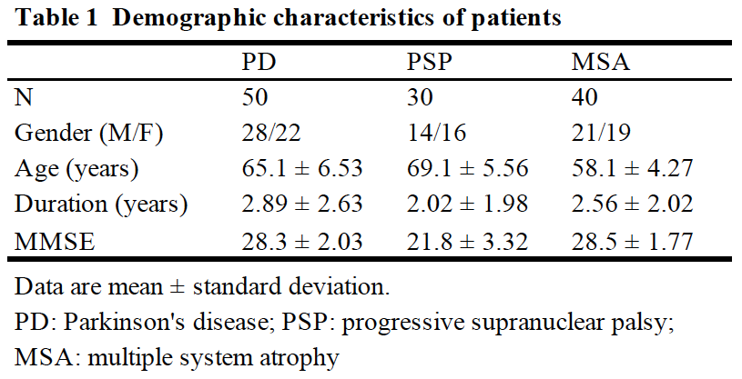
----------------------------------------------------------------------------------------------------------------------------------------------------------------------------------------------------------------------------------------------------------------------------------------------.
-------------------------------------------------------------------------------------------------------------------------------------------------------------------------------------------------------------------------------------.
---------------------------------------------------------------------------------------------------------------------------------------------------------------------------------------------------------------------------------------------------------------------------------------------------------------------------------------------------------------------------------------------------------------------------------------------------------------------------------------------------------------------------.
Figure 1. MMSE (Figure title, Times New Roman 6pt, bold)
MSA is the highest-------------------------------------------------------------------------------------------- (Figure legends, Times New Roman 6pt).

---------------------------------------------------------------------------------------------------------------------------------------------------------------------------------------------------------------------------------------------------------------------------------------------------------------------------------------------------------------------------------------------------------------------------------------------------------------------------------------------------------------------------.
---------------------------------------------------------------------------------------------------------------------------------------------------------------------------------------------------------------------------------------------------------------------------------------------------------------------------------------------------------------------------------------------------------------------------------------------------------------------------------------------------------------------------.
---------------------------------------------------------------------------------------------------------------------------------------------------------------------------------------------------------------------------------------------------------------------------------------------------------------------------------------------------------------------------------------------------------------------------------------------------------------------------------------------------------------------------.
---------------------------------------------------------------------------------------------------------------------------------------------------------------------------------------------------------------------------------------------------------------------------------------------------------------------------------------------------------------------------------------------------------------------------------------------------------------------------------------------------------------------------.
-----------------------------------------------------------------------------------------------------------------------------------------------------------------------------------------------------------------------------------------------------------------------------------------------------------------------------------------------------------------------------------------------------------------------------------------------------------------------------------------------------------------------------------------------------------------------------------------------------------------------------------------------------------------------------------------------------------------------------------------------------------------------------------.

DISCUSSION
PD is -----.¹ MSA is -----.²⁻⁴ Pathology of -------------------------------------------------------------------------------------------------------------------------------------------------------------------------------------------------------------------------------------------------------------------------------------------------------------------------------------------------.
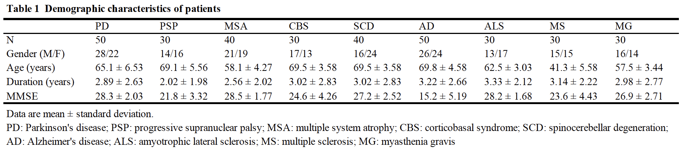
------------------------------------------------------------------------------------------------------------------------------------------------------------------------------------------------------------------------------------------------------------------------------------------------------------------------------------------------------------------------------------------.
----------------------------------------------------------------------------------------------------------------------------------------------------------------------------------------------------------------------------------------------------------------------------------------------------------------------------------------------------------------------------------------------------------------------------------------------------------------------------------------------------------------------------------------.
----------------------------------------------------------------------------------------------------------------------------------------------------------------------------------------------------------------------------------------------------------------------------------------------------------------------------------------------------------------------------------------------------------------------------------------------------------------------------------------------------------------------------------------.
-------------------------------------------------------------------------------------------------------------------------------------------------------------------------------------------------------------------------------------------------------------------------------------------------------------------------------------------------------------------------------------------------------------.
CONCLUSION
------------------------------------------------------------------------------------------------------------------------------------------------------------------------------------------------------------------------------------------------------------------------------------------------------------------------------------------------------------------.
AUTHOR CONTRIBUTIONS
------------------------------------------------------------------------------------------------------------------------------------------------------------------------------------------------------------------------------.
ACKNOWLEDGMENTS
-----------------------------------------------------------------------------------------------------------------------------------------------------------------.
-------------------------------------------------------------------------------------------------------------------------------------------------------------------------------------------------------------------------------------------------------------------.
FUNDING
-------------------------------------------------------------------------------------------------------------------------------------------------------.
CONFLICT OF INTEREST
------------------------------------------------------------------------------------------------------.
---------------------------------------------------------------------------------------------------------------------------------------------------------------------------------------------------------------------------------------------------------------------------------------------------------------------------------------------------------------------------------------------------------------------------------------------------------------------------------------------------------------------------.
-----------------------------------------------------------------------------------------------------------------------------------------------------------------------------------------------------------------------------------------------------------------------------------------------------------------------------------------------------------------------------------------------.

REFERENCES (Vancouver style, 8pt)
- Postuma RB, Gagnon JF, Bertrand JA, Génier Marchand D, Montplaisir JY, Pelletier A, et al. Parkinson risk in idiopathic REM sleep behavior disorder: preparing for neuroprotective trials. Neurology. 2015;84(11):1104-13.
- Spillantini MG, Schmidt ML, Lee VM, Trojanowski JQ, Jakes R, Goedert M. α-Synuclein in Lewy bodies. Nature. 1997;388(6645):839-40.
- Kandel ER, Schwartz JH, Jessell TM, Siegelbaum SA, Hudspeth AJ. Principles of Neural Science. 5th ed. New York: McGraw-Hill; 2013.
- Hardy J, Revesz T. The spread of neurodegenerative disease. In: Litvan I, Tolosa E, editors. Parkinson’s Disease and Related Disorders. Basel: Karger; 2007. p. 24-37.

